      

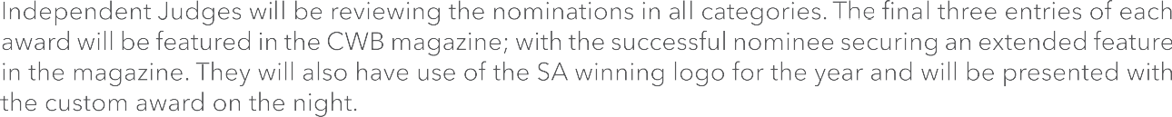



*5 6*



     





 ‘Let Us Entertain You’ 





|  |  |
| --- | --- |
|  |  |
|  |  |
|  |  |
|  |  |
|  |  |
|  |  |

